**HTML:**

<!DOCTYPE html>

<html>

<head>

<meta charset="UTF-8">

<meta name="viewport" content="width=device-width, initial-scale=1.0">

<title>HP Fitness</title>

</head>

<link href="https://fonts.googleapis.com/css?family=Baloo+Bhai&display=swap" rel="stylesheet">

<link rel="stylesheet" href="style.css">

<style>

</style>

<body>

<header class="header">

<!-- Left box for logo -->

<div class="left">

</div>

<!-- Mid box for navbar -->

<div class="mid">

<ul class="navbar">

<li><a href="#" class="active">Home</a></li>

<li><a href="#">About Us</a></li>

<li><a href="#">Fitness Calculator</a></li>

<li><a href="#">Contact Us</a></li>

</ul>

</div>

<!-- Right box for buttons -->

<div class="right">

<img src="gymlogo.jpg" alt="" class="center" class="img-fluid img-responsive">

<div>HP Fitness</div>

<button class="btn">Call Us Now</button>

<button class="btn">Email Us</button>

</div>

</header>

<div class="container">

<h1>Join the best gym of Pune now</h1>

<form action="noaction.php">

<div class="form-group">

<input type="text" name="" placeholder="Enter your Name">

</div>

<div class="form-group">

<input type="text" name="" placeholder="Enter your Age">

</div>

<div class="form-group">

<input type="text" name="" placeholder="Enter your Gender">

</div>

<div class="form-group">

<input type="text" name="" placeholder="Enter your Locality">

</div>

<div class="form-group">

<input type="text" name="" placeholder="Enter your Email Id">

</div>

<div class="form-group">

<input type="text" name="" placeholder="Enter your Phone Number">

</div>

<button class="btn">Submit</button>

</form>

</div>

</body>

</html>

**CSS:**

body{

font-family: 'Baloo Bhai', cursive;

color: white;

margin: 0px;

padding: 0px;

background: url('gym.jpg');

height: 100%;

}

.left {

display: inline-block;

position: absolute;

left: 60px;

top: 20px;

}

}

.mid {

display: block;

width: 36%;

margin: 29px auto;

width: 136px;

filter: invert(100%);

}

.right img {

width: 136px;

filter: invert(100%);

}

.right {

position: absolute;

right: 34px;

top: 43px;

display: inline-block;

}

.center {

display: block;

margin-left: auto;

margin-right: auto;

width: 50%;

}

.right div {

line-height: 19px;

font-size: 26px;

text-align: center;

}

.navbar {

display: inline-block;

}

.navbar li {

display: inline-block;

font-size: 25px;

}

.navbar li a {

color: white;

text-decoration: none;

padding: 34px 23px;

}

.navbar li a:hover,

.navbar li a.active {

text-decoration: underline;

color: grey;

}

.btn {

font-family: 'Baloo Bhai', cursive;

margin: 0px 9px;

background-color: black;

color: white;

padding: 4px 14px;

border: 2px solid grey;

border-radius: 10px;

font-size: 20px;

cursor: pointer;

}

.btn:hover {

background-color: rgb(31, 30, 30);

}

.container h1 {

text-align: center;

color: white;

background-color: black;

}

.container {

border: 2px solid white;

margin: 106px 80px;

padding: 75px;

width: 33%;

border-radius: 28px;

}

**OUTPOT:**

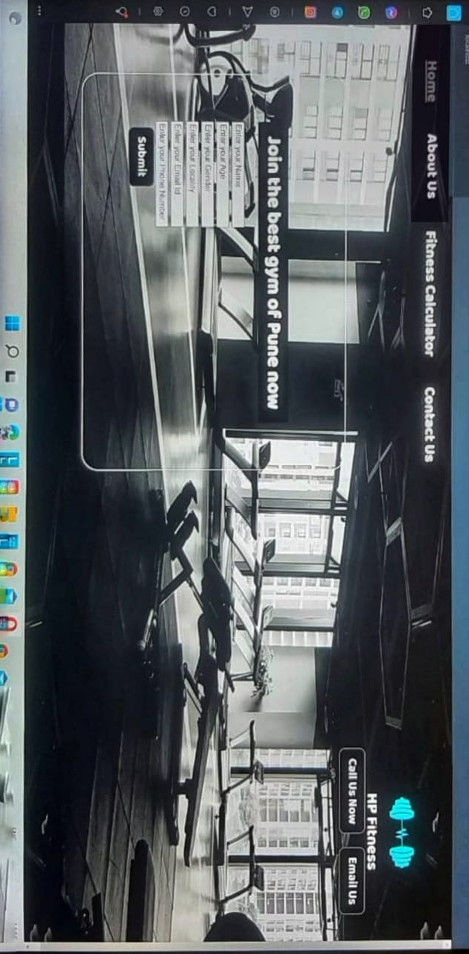

**JQUERY WEBSITE:**

<!DOCTYPE html>

<html>

<head>

<title>jQuery Mobile</title>

<link

rel="stylesheet"

href="https://code.jquery.com/mobile/1.4.5/jquery.mobile-1.4.5.min.css"

/>

<script src="https://code.jquery.com/jquery-1.11.1.min.js"></script>

<script src="https://code.jquery.com/mobile/1.4.5/jquery.mobile-1.4.5.min.js"></script>

</head>

<body>

<div data-role="page">

<div data-role="header">

<h1>Web Technologies</h1>

</div>

<div data-role="main" class="ui-content">

<h4>Web Technologies</h4>

<p>

This article is about the online encyclopedia. For Wikipedia's home

page, see Main Page. For the English edition, see English

Wikipedia.For a list of Wikipedias in other languages, see List of

Wikipedias. For other uses, see Wikipedia (disambiguation).

</p>

<p>

<b>1. Browsers</b> - Browsers request information and then they show

us in the way we can understand. Think of them as the interpreters of

the web. Here are the most popular ones: Google Chrome – Currently,

the most popular browser brought to you by Google Safari – Apple’s web

browser Firefox – Open-source browser supported by the Mozilla

Foundation Internet Explorer – Microsoft’s browser.

</p>

<p>

<b>2. HTML & CSS HTML</b>- is one of the first you should learn.

Thanks to HTML, the web browsers know what to show once they receive

the request. If you want to better understand how HTML works, you also

need to know what CSS is. CSS stands for Cascading Style Sheets and it

describes how HTML elements are to be displayed on the screen. If you

browse enough tutorials, you’ll soon create CSS text effects, page

transitions, image hover effects, and more. If you’re a complete

beginner, this Essential HTML & CSS training by James Williamson will

help you to quickly get started with these technologies.

</p>

<p>

<b>3. Web Development Frameworks</b> - Web development frameworks are

a starting point of items that a developer can use to avoid doing the

simple or mundane tasks, and instead get right to work.

</p>

</div>

<div data-role="footer" data-position="fixed">

<h4>&copy; copyright 2022</h4>

</div>

</div>

</body>

</html>

**OUTPUT:**

